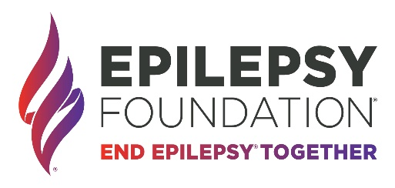
Deadline: Must be received or post-marked by May 1, 2024

THE IRA ROSENZWOG MEMORIAL SCHOLARSHIP APPLICATION FORM
Vision: Administered by the Epilepsy Foundation – Maryland. The recipient of the 2024 Ira Rosenzwog Memorial Scholarship will be a student who shows courage when dealing with epilepsy and seizures, a strong commitment to their education, and must reside in Maryland.
Criteria: Two scholarships will be awarded to students living with epilepsy for use towards undergraduate tuition at a 2-year college, 4-year college, or a trade/technical school in the amount up to $4,000 per year. Students must maintain a 2.5 GPA. Semester grades must be submitted to continue to receive the award.
PART 1: GENERAL INFORMATION (Please print or type)
Applicant name: _____________________________________________________________ Age: __________
Address: __________________________________________________________________________________
City: _________________________ State: ____________ Zip: _________ Telephone: ___________________
E-Mail: ___________________________________________________________________________________
Parent Name: ______________________________ Parent E-Mail: ___________________________________
Are you currently being treated by a physician for epilepsy? Yes☐ No☐ Who: _________________________
Are you presently taking anticonvulsant medication? Yes☐ No☐
How did you hear about this scholarship? __________________________________________________________________________________________
PART 2: ACADEMIC INFORMATION
Name of High School: ________________________________ Expected Graduation Date: ________________
Address of High School: ____________________ City: ______________ State: __________ Zip: __________
Type of school you’re interested in attending: ☐ 2-year College/University
☐ 4-year College/University
☐ Trade or Technical School
Current Grade Point Average: _____________________ Highest Total Score; SAT: _______ or ACT: _______
List any academic awards or honors you have received: ____________________________________________________________________________________________________________________________________________________________________________________

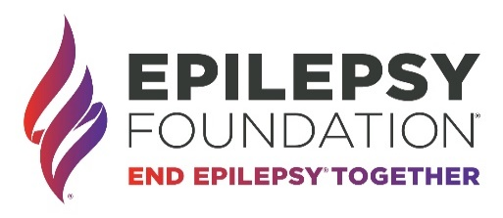

PART 3: EXTRACURRICULAR ACTIVITIES, COMMUNITY INVOLVEMENT, OR WORK EXPERIENCE
Describe your participation in any activities, organizations, sports, groups, community service, or work experience: ________________________________________________________________________________________________________________________________________________________________________________________________________________________________________________________________________________________________________________________________________________________________________
PART 4: FINANCIAL INFORMATION
Approximate Annual Household Income (Check one box):
☐ $0-$25,000 ☐ $25,001-$50,000 ☐$50,001-$75,000 ☐$75,001-$125,000 ☐ $125,001-$150,000☐ $150,001-$200,000 ☐ More than $200,000 Number of Household Members: ____________
Describe any special circumstances we should consider with regard to your family’s current financial standing: ____________________________________________________________________________________________________________________________________________________________________________________
Estimated tuition expenses: ___________________________________________________________________
List other scholarships you applied for, indicate the award amount, and the status of your application.
Scholarship Name | Award Amount | Awarded | Declined | Undetermined
Click or tap here to enter text. | Click or tap here to enter text. | ☐ | ☐ | ☐
Click or tap here to enter text. | Click or tap here to enter text. | ☐ | ☐ | ☐
Click or tap here to enter text. | Click or tap here to enter text. | ☐ | ☐ | ☐
PART 5: ESSAYS
Please provide a one-page essay explaining why you should be selected for this scholarship. Please include:
- How has epilepsy affected your life?
- What do you hope to gain from your college experience?
PART 6: ENCLOSURES
- Submit two letters of recommendations with this application. One letter of recommendation must be from the neurologist treating your epilepsy. The second recommendation can be from a teacher, academic advisor, principal, coach, employer, or clergy.

- Attach an unofficial copy of your current transcript.
Return application and enclosures to Kira Eyring: keyring@efa.org or by mail: 2427 Southwest Road Baltimore, MD 21234
Questions: Contact Kira Eyring at keyring@efa.org or 410-916-0984
Deadline is May 1, 2024

