Build the Good - Cholesterol!

Why should we care about our Cholesterol levels?
Cholesterol levels are one of the numerous factors, such as blood pressure, age, smoking, and body composition, your doctor can use to assess or predict your cardiovascular risk. Bottom line, the more risk factors you have the more likely you are to have a cardiovascular event such as a heart attack or stroke.

The Cholesterol You Need

Cholesterol is essential to your overall health, so what do you really know about it? Cholesterol is a waxy substance the body needs to build cells, aid in digestion, convert Vitamin D in the skin and develop hormones. The liver produces all the cholesterol the body actually needs. Consumption of foods derived from animals and some tropical oils (foods high in saturated and trans fats) cause the liver to produce more cholesterol. For some people, this added production means they go from a normal amount of cholesterol in the bloodstream, to one that’s unhealthy.

How does Cholesterol work?
Well, that cholesterol produced, and overproduced by the liver and sent out into the bloodstream comes in two main types LDL, or Low-Density Lipoprotein and HDL, or High-Density Lipoprotein.
- LDL, known as ‘bad’ cholesterol, can build up inside arteries, narrowing vessels, increasing risk of blockage and heart attack or stroke.
- HDL, commonly known as ‘good’ cholesterol, acting as a scavenger, carries LDL away from arteries back to the liver to be broken down and passed from the body.
- A Third component, Triglycerides, are the most common type of fat in the body. Their job is to store excess energy or fat from your diet. High levels are linked with that same fatty build up and risk of blockage as LDL.
High LDL + Low HDL + High Triglycerides = Increased fatty buildup within artery walls and Increased risk for Heart Disease. (See Image Below)
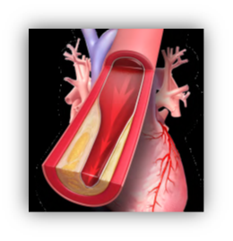

Cholesterol – The Good News!
- There are many ways to improve your Cholesterol numbers and reduce your Cardiovascular Risk.
- Increasing your HDL Cholesterol can help control your LDL Cholesterol.
- Many things that improve Cholesterol also help reduce other risk factors.
We can Help! Keep Reading!

Healthy Cholesterol looks like . . .

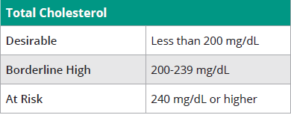

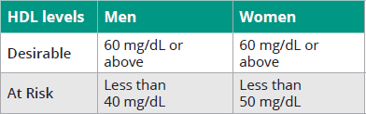

Next Steps – Know Your Numbers

Connect with your Primary Care Physician (PCP)

It’s important to visit your doctor at least once a year for your Annual Wellness exam to stay aware of where your numbers stand and ensure they are not getting worse over time.

Tips for Improving Cholesterol
Work with your healthcare provider on an agreed upon plan that works best for you and your family. For support, encourage your whole family to join you in your heart-healthy lifestyle.

This includes:
- Making sure you understand what cholesterol is and how to manage it
- Knowing your risks for heart disease and stroke and how to reduce them
- Eating a heart-healthy diet
- Getting regular physical activity
- Reaching and maintaining a healthy weight
- Avoiding smoking products
- If choosing medication, take as prescribed, and reporting any side effects to your PCP

CareFirst/Sharecare can help too! To Register go to Carefirst.com/Sharecare.

Health Coaching
Receive individual Coaching targeting areas like: Healthy Eating, Weight or Stress Management, Healthy Eating, and Tobacco Cessation.

Scale Back

Reduce your disease risk and lose weight with Scale Back! Work collaboratively with a Registered Dietician and Health Coach to learn how to eat healthier, lose weight, and maintain your weight loss!

Tobacco Cessation
Find support through mindfulness tactics and support tools so you can be on the path to becoming tobacco free with Craving to Quit Tobacco Cessation program.

National Resources
Whether you’re an individual managing your own Cholesterol or an organization looking for resources for your employees, check these out:
- American Heart Association – print fliers, access videos, and more: https://www.heart.org/en/health-topics/cholesterol/cholesterol-tools-and-resources
- CDC Handouts: https://www.cdc.gov/cholesterol/materials_for_patients.htm
- CDC Communications Kit for Organizations: https://www.cdc.gov/cholesterol/communications-kit.htm
- American Diabetes Association: https://www.diabetes.org/nutrition/healthy-food-choices-made-easy/fats

