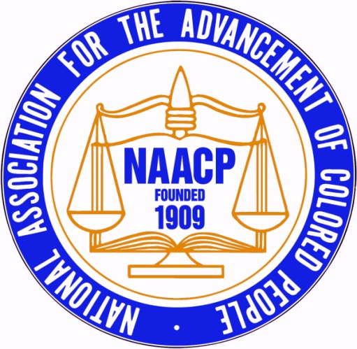 | BOND/CHANDLER MEMORIAL SCHOLARSHIP  2019 Scholarship Application
First Name: |  | Last Name:
Date of Birth: |  | Contact Number:
E-mail:
Street Address: |  | City, State, Zip
Parent/Guardian #1 First and Last Name
Street Address: |  | City, State, Zip
E-mail:
Contact Number:
Parent/Guardian #2 First and Last Name
Street Address: |  | City, State, Zip
E-mail:
Contact Number:
Current Academic Status:
High School Name:
High School Address:
Reading & Writing SAT Score:
Math SAT Score:
Cumulative GPA:
Class Size:
Class Rank:
Have you taken AP Classes? |  | How many?
Have you taken College Courses? |  | How many?
College Acceptances Received (list all):
College you are attending in Fall 2019
Enrollment type: □Full-Time □ Part-Time |  | Major:
2019 Scholarship Application
Requirements and Directions
Thank you for your interest in applying to the BOND/CHANDLER MEMORIAL SCHOLARSHIP. Please carefully read the requirements below for submitting an application. The Harford County NAACP Chapter will award five (5) scholarships this academic school year.
REQUIREMENTS TO APPLY FOR A 2019 SCHOLARSHIP:

Each applicants is required to submit ALL of the following documents:
a completed 2019 Scholarship Application form,
a current high school transcript
two letters of recommendation in PDF form
Applications are only accepted by e-mail; all required documents must be sent together in one e-mail, and must be sent to jthornton@thorwoodreg.com.
Applicant must be a high school senior (Public or Private School)
Bonus Consideration
Please note the following additional information:
We are looking for students who are committed to issues related to equity, social justice and the advancement of diversity in our community
Joseph Bond and Eugene Chandler were champions for human and civil rights and equity in education.
- Please explain how you emulate these characteristics and embrace diversity in your community and school.
We will consider scholarship applicants who are pursuing post-secondary education or training; this may include two or four year college programs, or certification programs.
Applicant must be graduating from high school in May/June 2019.
All applications with supporting documentation must be received no later than 6 p.m. n April 19, 2019.

