The Judy Center at Magnolia Elementary School
901 Trimble Road - Joppa, MD 21085
Phone: 410-612-1553 Fax: 410-612-1576

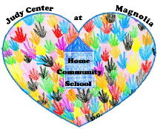

Agency Referral

Parent Name __________________________________________________________________

Address ______________________________________________________________________

Telephone ____________________________________________________________________

Home Work Cell

Children: Names DOB/ Age

______________________________________________________________________________

______________________________________________________________________________

______________________________________________________________________________

Programs interested in:

Playgroups Health

Parent Workshops/ Support Group Dental

Parent Continuing Education Behavior

Computer Classes Child Care

Dads’ Programs Parent as Teachers

Other ________________

Referred by ____________________________________Date __________________________

Agency _______________________________________________________________________

Comment:
______________________________________________________________________________

______________________________________________________________________________

______________________________________________________________________________

______________________________________________________________________________

